Josquin 500  Workshop for voices and instruments  directed by Patrick Craig  Saturday 6 November 2021  Scaynes Hill Village Centre  Patrick has chosen three beautiful Marian motets, three Agnus Dei from Josquin’s mass settings, and the Qui habitat a 24. He will no doubt inspire us with his informative talks about these works on the day.  Voices: all voices welcome  Open to all instruments, including:  Cornetts, sackbuts, curtals/dulcians, recorders, viol and violin family, plucked continuo. Violin family players do not need to have a baroque instrument.  Scores and parts will be available on the day. Pdfs of the vocal scores can be provided in advance on request. Instrumentalists, please bring a stand.  Pitch is A=440.  Fee: £20.00 for members of SEMF and other Fora and £26.00 for non-members.  Acceptance will be subject to musical balance.  Deadline for applications is 29 October. Later applications (if accepted) attract a £2 surcharge.  The workshop will be organised in line with the advice of Making Music on organising ‘covid-secure’ rehearsals. Information on key safety measures to be followed on the day will be sent to participants beforehand.  If you have to cancel because of covid symptoms and/or a positive test, or because you have to self-isolate, fees will be refunded on request (please email the organiser). We regret we cannot otherwise refund fees for late cancellations.  Joint organisers: Janet Gascoine and Jenny Frost  Queries to Jenny: email jennyfrost@waitrose.com,  tel 01634 241986  Mobile nos, for emergencies only  Jenny - 07740 951253  Janet – 07933 039489 |  | 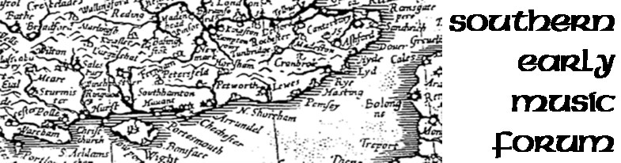  Patrick Craig is a countertenor, conductor and lecturer, who has recently run four workshops for SEMF as well as three very popular Zoom sessions. He has recently completed twenty-five years as a Vicar Choral at St Paul’s Cathedral. For twenty years he sang a thousand concerts with the Tallis Scholars, touring the world. Patrick is also a member of The Cardinall’s Musick, who won the coveted Gramophone Record of the Year Award in 2010. He founded and conducts Aurora Nova, this country’s foremost professional all-female choir, who have sung services for 70 Sundays at St Paul’s Cathedral since 1997. He leads workshops for Lacock Courses and Early Music Forums across the country. He has also lectured for John Hall Venice Courses, for St Paul’s Cathedral Adult Education Department, and is now an accredited Arts Society lecturer.  Venue: Scaynes Hill Village Centre, Lewes Rd, Scaynes Hill, Haywards Heath, RH17 7PG. The Centre is on the A272, about 15 minutes’ drive from Haywards Heath. It may be possible to arrange lifts from Haywards Heath Station. Scaynes Hill has several pubs, but you may wish to bring a packed lunch.  .  Timetable: Arrival from 10.30 am (please do not arrive before then). Music begins at 11.00 and finishes at 5.00 pm with breaks for lunch and tea.  The Southern Early Music Forum is one of 9 regional groups encouraging the understanding and appreciation of early music. For more information see www.semf.org.uk.

SEMF workshop for voices and instruments, Scaynes Hill Village Centre, Saturday 6 November 2021
Please return this form as soon as possible (and before 29 October) to:
Jenny Frost, 109 Kent Rd, Halling, Rochester, Kent ME2 1AT, email jennyfrost@waitrose.com
I belong to ………………………… Early Music Forum/please send me information about joining SEMF
I enclose a cheque made payable to “Southern Early Music Forum” (not “SEMF”) for £……………
OR I have paid £................... by electronic transfer Electronic payments: See web page Electronic payments .
Please include your name and ‘PC’ and notify treasurer@semf.org.uk and jennyfrost@waitrose.com
Name: ........................................................................................... Phone: .......................................................
Email: ......................................................................................................OR I enclose SAE (delete as applicable)
Address................................................................................................................................................................................................................................................................................................
I would like a lift from Haywards Heath station: Yes/No
I can offer a lift from Haywards Heath station: Yes/No

Voice (SATB etc) ......................................... Please indicate comfortable range (S1, S2 etc)
Sight-reading: good/fair/adequate (delete as applicable)
Please also indicate if you would be willing to play an instrument in Qui habitat, for which we will allocate 24 instruments so that singers do not need to sing a part unaided: I am willing to play .............. [instrument] in Qui habitat

Instrument(s) .......................................................
Standard: advanced/intermediate (delete as applicable)

To help protect everyone we are asking all participants (vaccinated or not) to take a free rapid (lateral flow) covid test the day before the workshop. These are available from pharmacists or can be ordered online.

Please tick the boxes below as appropriate:

I have been fully vaccinated (2nd dose at least two weeks before the workshop)

I will take a rapid lateral flow test the day before the workshop

I will help to protect everyone by following the organisers’ safety rules

If you have received a positive test, or have any symptoms of covid-19, or have been asked to
self-isolate, please do not come to the workshop and let the organiser know. Your fee will be refunded on request

